Professor Krayer
AOSC 100: Case Study
Snow Problem!
An AOSC 100 Case Study
Part I: The Prerequisites
Introduction
For my case study I chose to research a large snowstorm effecting the east coast of the United States. The reason for that is simple. I spent most of my childhood and adolescence living in the foothills and mountains of West Virginia, and while I don’t have much experience with tornados or hurricanes, I know snow. This makes this an easy topic for me to relate to, and hopefully an interesting topic to research given my prior experience with severe snow.
The news media has many nicknames of varying accuracy sensationalism, and even sometimes irony they use to describe active weather events involving snow. Some past examples are ‘Snowmageddon’, used to describe multiple snow storms this decade, but most commonly associated with the blizzard that battered the DC metropolitan area in 2010, and ‘the Snowpocalypse’ which refers to different storms depending on the context, and which seems to often be used ironically online to refer to insignificant amounts of snow that gets a disproportionate amount of buzz ahead of time. What we can tell from all these nicknames, however, is that my interest in snowstorms is not unique, but extends to the culture at large.

Chasing A Storm
Looking for a specific snowstorm, I noticed that there weren’t a lot of noticeable snowstorms in winter of early 2019. I was able to find one snowstorm that was interesting, however, buffeting Albany with two feet of snow, leaving up to a foot in most of the direct region, and 3-6 inches of snow across the majority of New England. To be honest, I was at first slightly underwhelmed, not necessarily realizing how much that was, until noticing from the data that the amount of snow, and distribution (2 feet to 1 foot to 3-6 inches) was almost identical to the previously mentioned “Snowmageddon” hammering in both the magnitude of this storm, and ridiculousness of that name. Unfortunately for me, the snow fell between January 19th and January 20th, whereas the instructions for the case study said we had to pick a weather event on or after January 22nd. On the Weather.gov page for the storm it does say that the snowfall itself had passed through New York and New England on January 19th and 20th, it specifically mentions that “Frigid temperatures followed the Snow for Monday and Tuesday, January 21st and 22nd, with wind chills falling to -20 to -40F across most of the region” (“January 19-20, 2019 Snowfall,” 2019). I feel it is implicitly stated that Weather.gov considers this period of intense cold as being, at the very least caused by this weather event since they mention it in the overview, and as I will prove later, this period of intense cold can very reasonably be said to be not just caused by, but a part of the same weather event that caused the snowfall, bringing the active date for the system to January 22nd, and meeting the criteria for being current as defined by a liberal reading of the rules for this assignment.
Unfortunately, after looking for an interesting colloquial name for this weather event to use through the rest of this assignment and turning up empty handed, and failing that, trying to find a single reporter who might have called it something interesting in print at literally any point in time and still turning up nothing, I was left with the title provided by AccuWeather of “The Big Snow of January 2019” (Abrams 2019). which, though neither sensational nor ironic, is at least accurate. Since that’s still not very catchy, I’m just going to refer to the entire event from formation to the icy wave that stayed after the snow had fallen as “The Big Snow”. Fortunately, now that we have selected a weather event, explained my interest, explained why the article titled “January 19-20, 2019 Snowfall” actually proved that the weather event lasted until January 22nd, (conveniently, but coincidentally putting it in the allowed time frame) and finally given it a snazzy name we can move right on in to the good stuff.

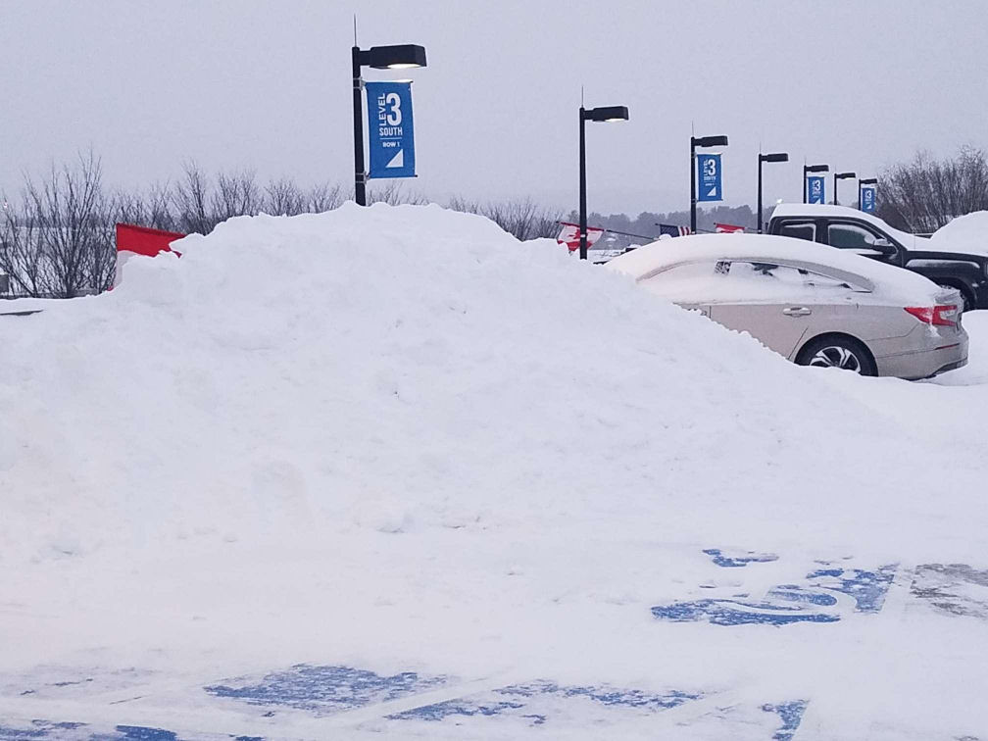
Photo is from an unknown New England Parking Garage on January 21

Part II: The Good Stuff
Background
Now that we know what we’re looking at, the question is where we should start looking, and what we should start with. What is an easy question, as surface maps are typically a good place to start, and will give us a lot of useful info, and a solid launching off point. The storm was at its peak at 12 z January 20th, so I think starting 12 hours earlier would probably show us some of the active weather systems that may have led to this snow storm.
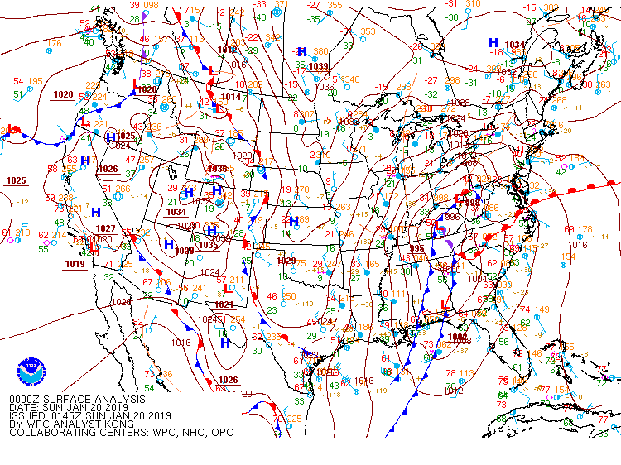
Retrieved from WPC Surface Analysis Archive. 1/20/19. 0Z.

This map, from 0 z reveals a lot of the conditions that probably led to the snowstorm. Firstly, we can see multiple cold fronts carrying low pressure systems that seem to be pushing East, and up. Note the oscillating front (more like a stationary front) over Kentucky, presumably where the cold front is beginning to push its way through (and under) the warm front between it and the North East. One other thing to take note of is the 1034 mb High Pressure system north west of Maine. It might play a part in why the Continental Arctic air mass was able to push into this area it would normally not play a factor in. (I’m assuming it’s a Continental Arctic front instead of a normal Continental Polar one because of the EXTREME low temperatures. If it was 0 or even -10, I would assume it was a normal Continental Polar front, but -20 to -40 seems way too cold for even a Continental Polar front.)
The reason I think this is related to the arctic blast is that high pressure systems circulate air clockwise in the northern hemisphere, and the proximity of this high-pressure system to the 1034 millibar we can see on the map (which is an EXTREMELY high millibar) and its geographical location in a fairly arctic part of Canada suggests to me that this high pressure system may have been able to circulate this air clockwise, taking it through Maine, and ultimately New York and the rest of New England. Normally I wouldn’t expect the high-pressure system to bring arctic air all that distance, but I figure its probably related to the 1034 millibar (which, remember, is a weirdly high millibar.) I assume then, that these two things are probably related, and that the higher than normal millibar is creating a higher than normal gradient, which is in turn allowing this arctic air to travel further than normal; all the way into central New England.

Analysis
Now that we’ve seen the surface map for 12 hours before the storm peaked, let’s look at the surface map from the peak of the snow storm itself and see what new observations we can make.
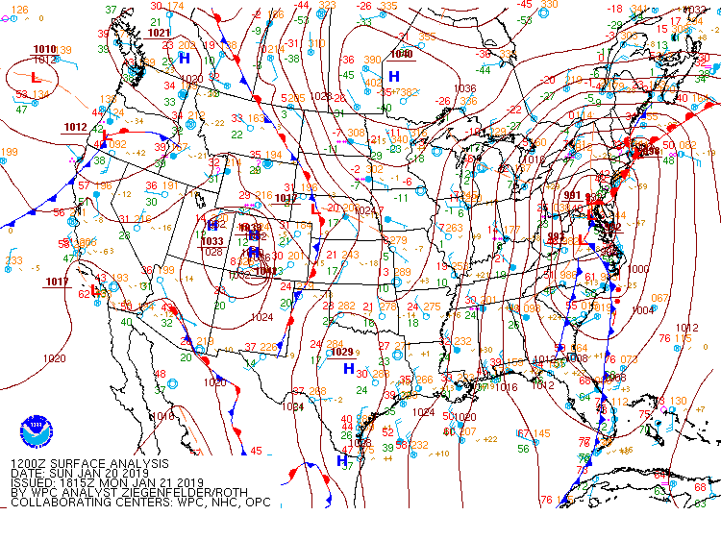
Also retrieved from WPC Surface Analysis Archive. 1/20/19. 12Z.
The first thing that came as a little bit of a surprise to me is that the low-pressure system seems to have solidly settled over Maryland and not over New England. Typically, we would expect low pressure systems to be directly associated with active weather, but here that was very much not the case. Even though it seems surprising at first glance, after looking more closely we can figure out why the snow fall centered North of the low-pressure area. One huge factor is that I can see not one but two shortwave throughs troughs northwest of Maryland; one normal small one (that still has the potential to massively effect affect weather by itself) and a massive one near the New York border. Shortwave Throughs can massively increase active weather, and its no surprise to me that the article I referenced earlier mentioned New York getting hit first by the severe snow since it is impacted by these short-wave throughs. Furthermore, even though this is the start of the severe snow, it continued for multiple hours, and judging by the movement of the low-pressure system from 0Z to 12Z, I figure if we give it a few more hours it’ll be right over New England. Let’s check.
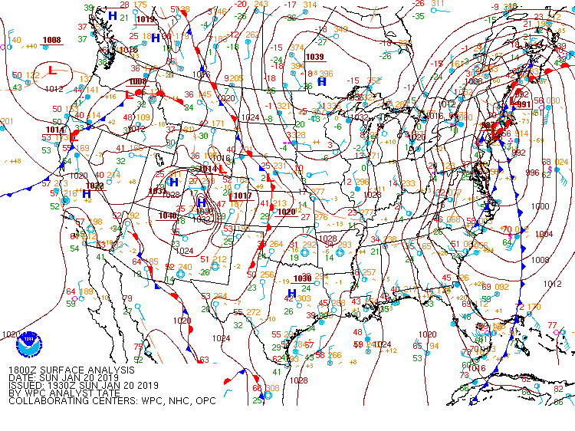
WPC Surface Analysis Archive. 1/20/19. 18z.
My prediction was partially correct. The low-pressure system did move north, but it stuck more to Rhode Island than New York or Vermont where I was expecting it based on the snowfall. The reason is simple though. New York is still getting BATTERED by those short-wave throughs, creating a very volatile environment ripe for active weather.
I don’t think Geography played a massive role in this in terms mountains or lakes, or the geographical features you would usually associate with weather/climate. It seems the physical location (i.e.: the dumb luck of being at the bottom of a steep millibar gradient bringing in air straight from the arctic.) I posit that Maryland and Virginia probably did have a decent amount of active weather that day, but simply were not cold enough to get a major accumulation of snow, either because the arctic winds did not reach that far, or (more likely) they simply hadn’t had time to reach that far by the time the active weather reached Maryland, but were sitting right over top of New York and New England, turning any precipitation they got into snow. To test this, I’m going to pull up a daily temperature map from the Department of Commerce Daily Weather Maps to check.
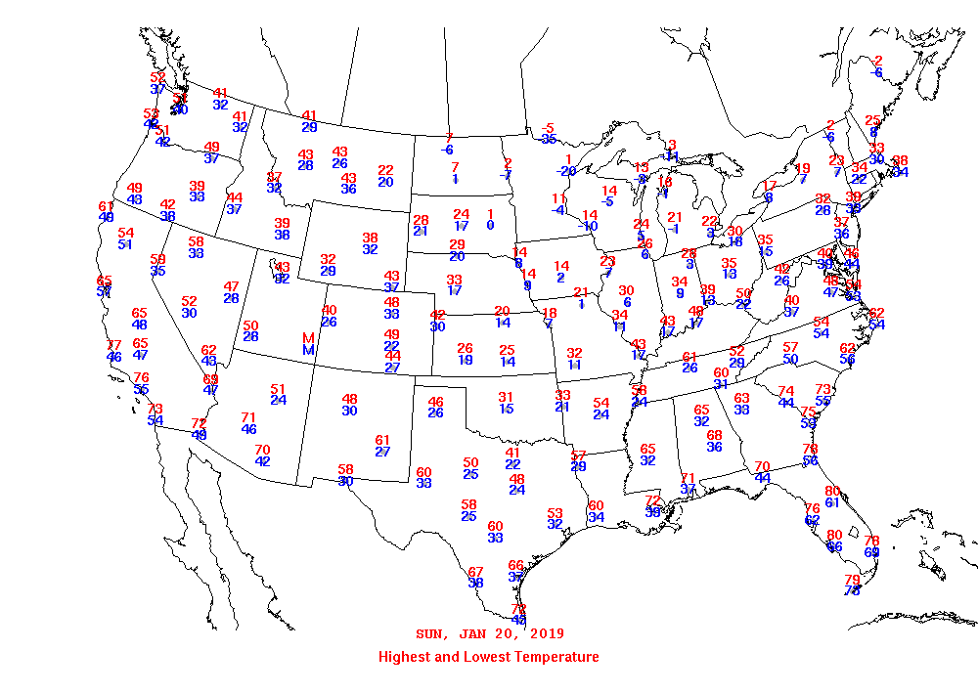
This theory absolutely seems to hold water, seeing as how the theoretical epicenter of the snow based on the low-pressure system (Maryland) was in the 30s and 40s all day, and 2 states over New York was getting single digit temperatures.
Continued Analysis – Factor Evaluation
I think we can accurately see a surprising number of factors that played into this storm just based on the surface maps, but maybe we can find some additional factors at play by looking at some upper level maps. To do this, I’m going to compare this storm to the “Terrible 10” checklist we got in class to see A: How easily predicted this snow was/could have been using the same criteria to look for regular storms and B: If any of the common factors observed leading to active weather may have played a part in addition to the unique factors we’ve already discussed. To do this we’ll go down the checklist one by one.
1: Will there be a weather front of any kind near the location in question
Yes. There is a cold front passing over New England, so that one gets a check
2: Is the weather front sharp enough to produce changes in temperature and/ or dew point of greater than 15 degrees.
Yes. We don’t even need to look at dew point for this one, lets just look at one of those basic simple temperature graphs like the one I pulled up earlier and compare New York from the 19th to the 20th. 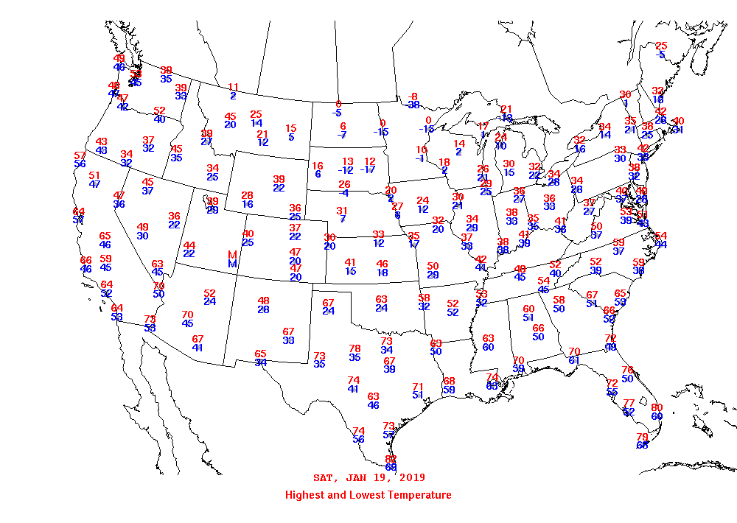
And looking at the previous temperature graph, we can see that temperatures in New York dropped from the mid-thirties, to the tens, so this one’s another yes.
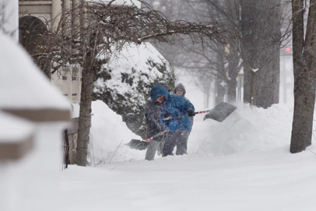
People in Albany shoveling snow. January 22, 2019.
3: Is the expected time of severe weather during the afternoon or early evening.
Kind of. It was a large event that effected varying places for varying lengths of time, in general starting in the morning and lasting until the early afternoon. Since the snowfall peaked in the morning, I’m going to give this one a no, however.
4: Are the Dew Points high: Above 50 in the winter/fall.
No, for the most part they don’t appear to be, and there doesn’t seem to be any correlation to active weather in the areas where there are.
5: Are the winds coming at 30 knots or greater from a large source of water
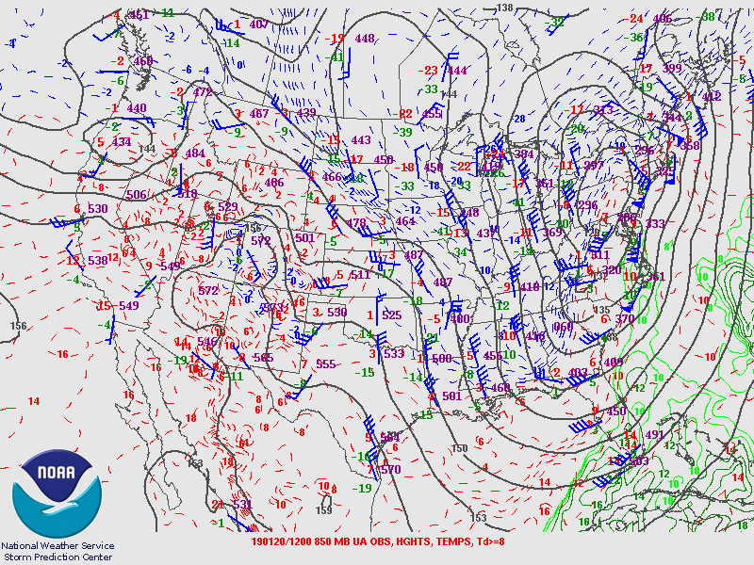

Not really. To be fair, this are a few areas where that is the case, there is also weak winds coming from water, and strong winds coming from dry areas, and weak winds coming from dry areas. To be honest this whole map is kind of a mess, and the amount of divergence from the wind suggests there is some crazy weather going on, but I think you could chuck that to chance. I don’t know, ill I’ll give it a half, I guess.
6: Do the 500 and 700 mb upper air maps show a long wave trough directly to the west, and short-wave troughs near the location?
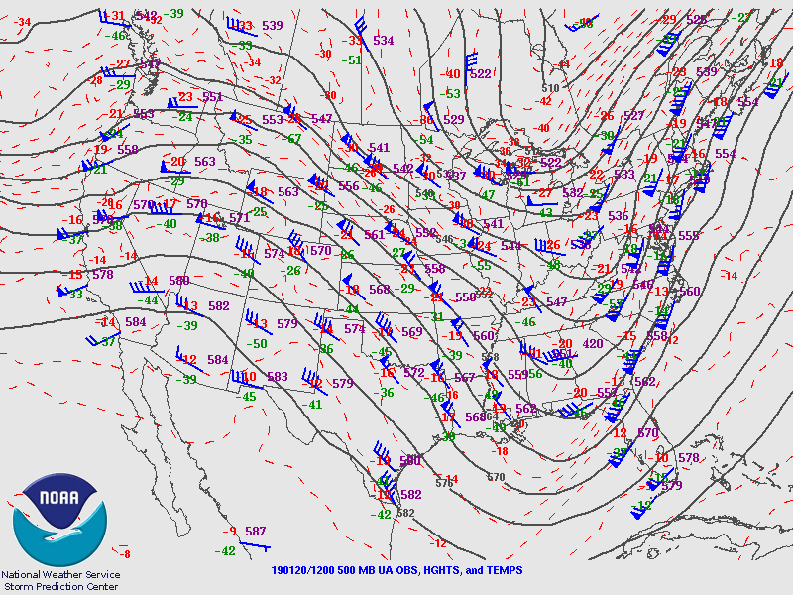
500mb
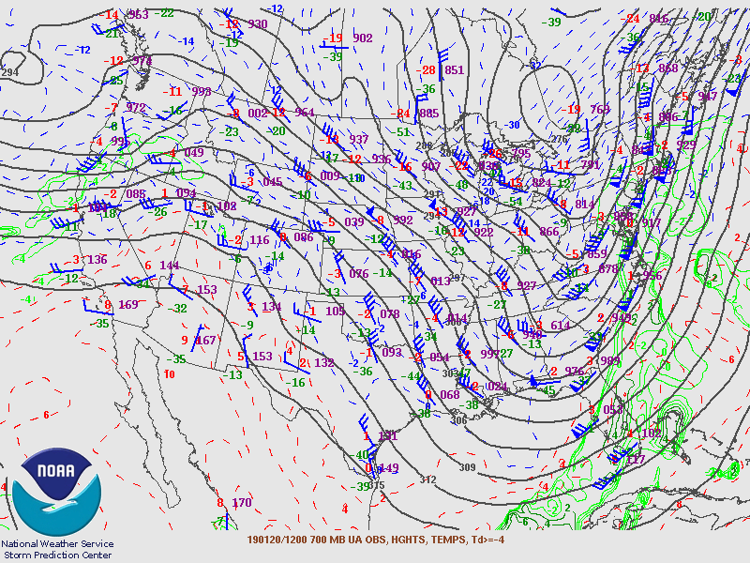
700mb
I see a long wave through to the west in the 500, and I see both the long and short waves in the 700. Long story short, yes.

7: Is the area under the effect of a jet streak, especially the right entrance or left exit quadrants, when looking at the 300/250mb map.
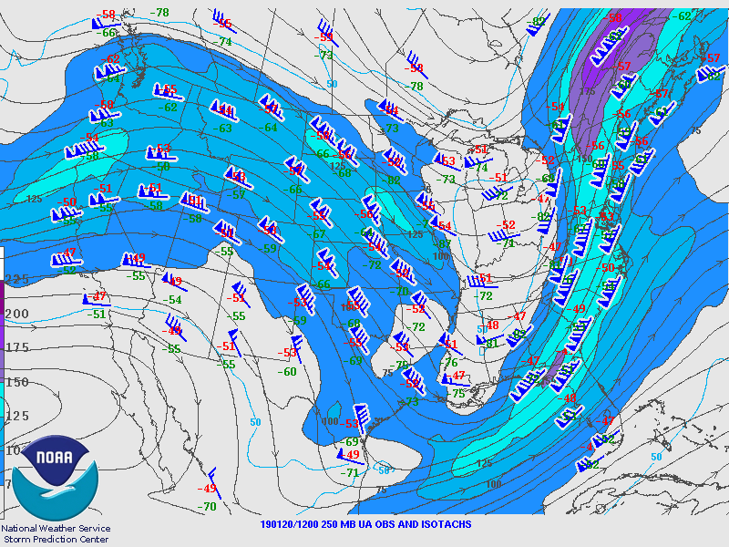
250mb
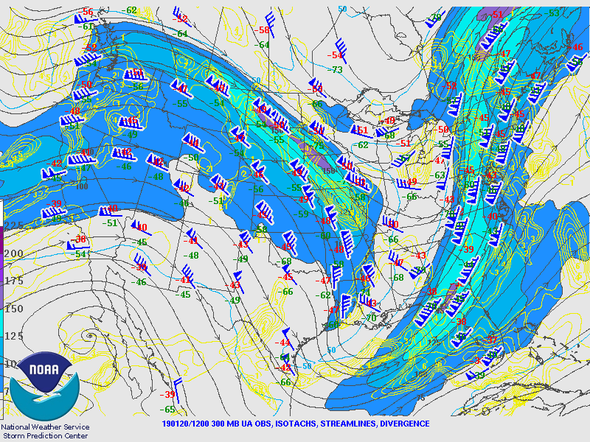
300mb
It appears that this region is under a jet stream that starts before the region and ends after it, so its going to be a yes, but without much oomph to it.
8: Do the 250 mb and 300 mb maps show divergence.
No, they’re parallel.
9: Looking at the Stuve soundings do the winds change counterclockwise going from 300 to surface. 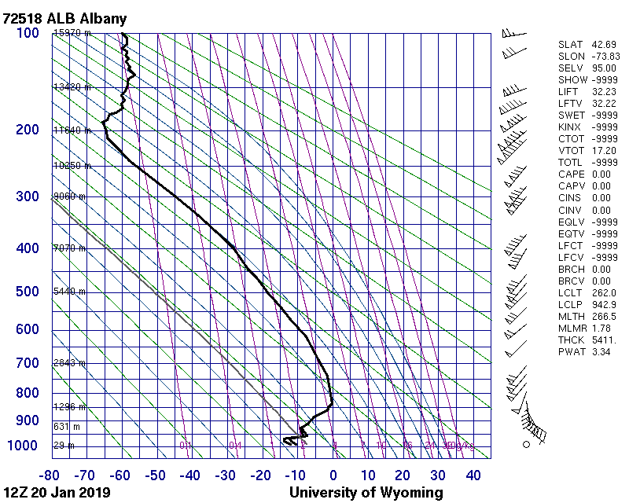
Yes, they do. There’s not much change at first, and a strong one at the end; but it’s still noticeable.
10: On the Stuve readings, is LIFT below 0 and/or TOTL>50
LIFT is well above 0, TOTL is reading as -9999, which I’m going to assume means something went wrong. I’m going to mark a SOLID no and an inconclusive as a no.
Results: 4.5 yes, 5.5 no
I think the results here make sense. I was intentionally using a system designed to detect storms to detect snow, which is a very different beast entirely. I expected some of the indicators of atmospheric instability to be the same, and some not to be, so my answers don’t surprise me at all. It seems from my admittedly limited data pool that some indicators like time of day, and winds (both jet streams and divergence) aren’t going to work as indicators for snow storms, while other indicators like presence of a front, strength of a front, and long/short wave throughs are still very much factors.
Causes
I’ve been listing factors and causes throughout this paper, but I’ll tie them together here in a single place, to give my final thoughts after everything. I think that a strong gradient ended up dropping some freezing arctic air over top of New England around the same time a regular cold front was coming in from the south branching off from a warm front which impacted the states around Maryland and Virginia instead. Even though the low pressure system was actually solidly centered around the Maryland DC area, the warm front, and just overall high temperatures prevented snow, whereas even though New England was further out from the low pressure system, the presence of both long wave throughs to the west, and short wave throughs all over the place amplified the active weather they would have normally gotten to make it so that they were actually the targets of the severe weather, which because of the temperatures fell as snow. In short, the snow wasn’t so much the result of a single band of cold snow moving into the region at all, but rather the result of warm rain coming in from the south and hitting this freezing arctic air, which created an unstable environment (in combination to the long and short wave throughs amplifying that) causing an area that wouldn’t have normally been majorly effected by rain from the south to not only be majorly effected by it (because of the long and short wave throughs) but for that rain to now fall as snow.

Part III: Conclusion
The most interesting thing about this weather event was that it turned out to actually be two weather events (a storm coming in from the south, and an arctic blast coming in from the north) that normally wouldn’t have even crossed paths getting thrown off coarse largely by the extremely disruptive power of short-wave throughs. I think this storm acts as a good case study for all these different concepts we’ve been learning about, because you can see not only that this snow storm wouldn’t have happened if any factor had been different, but exactly what would have happened depending on each factor. For example, if the arctic wave hadn’t been beginning (and already having lowered the temperatures below freezing on the way much colder) by the time the storm arrived, it would have just been rain. Furthermore, if this unrelated storm hadn’t been passing through it would have just been a dry arctic blast, and if other mitigating factors (like those dang short-wave throughs) hadn’t been in play, the arctic blast could been a regional New England concern, while the storm was a regional Maryland/DC/Virginia concern, with the two not having played off of each other to form the snow storm.
The data I got was hopefully accurate. It was a recent and local event, so fortunately I didn’t run into any problems getting data. There were multiple events where I wanted to use specific websites or tools that wouldn’t work, but fortunately there are enough websites that have surface and upper weather maps that it didn’t prove to be a huge issue.
I used some regular methods to evaluate snow near the beginning, which I can massively oversimplify as, active weather + cold = snow. I originally didn’t even realize the snow storm was coming from factors from 2 directions until I was already part way done, and I realized that if the storm was coming from the south, and the cold was coming from the north, than the snow was coming from both and neither of those. Having determined the factors for the snow storm, I was a little disappointed that I hadn’t even looked at most of the upper level maps at that point, so I decided to see how well methods of determining regular storms would also apply to snow storms.
Unfortunately, while I think it was interesting, and useful on a personal level (as it gave me the opportunity to use some of the skills we learned, and thus improve them) I don’t think this self-assigned challenge provided much useful data because of A: The small sample size, and more importantly B: the fact that this was not a snow storm that began as a single entity, but rather a regular storm hitting an arctic wave that fused into a snow storm in parts where both were present, and this data would not necessarily apply to predicting more traditional snow storms. Whether it is accurate or not, the data I got does make sense from a common sense perspective. Whether it’s true or not, it does make sense to me that snow storms would be impacted by long and short-wave throughs like regular storms, as well as fronts (cold fronts specifically) but not necessarily dependent on jet streams or divergent winds, or time of day.
As for additional data, I suppose I would just be interesting to gather data on snow in general. More specifically I’m curious how much of the time snow falling is the result of rain turning into snow at a previous point and traveling along as a snow storm now instead of a rain storm, snowing on people instead of raining on them vs. how much of the time it’s a wet and warm system hitting a cold and dry system to turn into snow storm over a localized area, and if these two would have very similar properties as weather systems, (i.e.: they’re both now snow storms and a snow storm is a snow storm) or would have different properties.

Part IV:References

Abrams, E. (2019). The Big Snow of January 2019. AccuWeather. https://www.accuweather.com/en/weather-blogs/abrams/the-big-snow-of-january-2019/70007140
Banacos, P., & Taber, B. The January 20-21, 2019 Winter Storm. National Weather Service.
https://www.weather.gov/btv/The-January-20-21-2019-Winter-Storm
Epstein, D. What We Know About This Weekends Forecast. Boston.com.
https://www.boston.com/weather/weather/2019/01/15/david-epstein-snow-storm-forecast-january-18-20
January 19-20, 2019 Snowfall. National Weather Service.
https://www.weather.gov/aly/19-20Jan2019Snow

Photos, Charts, Maps, and Graphs (by order of appearance)

Snow Pile in Parking Lot [Digital image]. (2019). Retrieved from https://www.weather.gov/btv/The-January-20-21-2019-Winter-Storm
WPC Surface Analysis Graphs [Digital image, multiple]. (2019). Retrieved from https://www.wpc.ncep.noaa.gov/archives/web_pages/sfc/sfc_archive_maps.php?arcdate=04/24/2019&selmap=2019042400&maptype=namussfc
Shoveling Snow [Digital image]. (2019). Retrieved from
https://dailygazette.com/article/2019/01/20/snows-and-dangerous-cold-to-hit-capital-region
Daily Weather Maps [Digital image, multiple]. (2019). Retrieved from
https://www.wpc.ncep.noaa.gov/dailywxmap/index_20190423.html
Storm Prediction Center Upper Air Maps [Digital image, multiple]. (2019). Retrieved from
https://www.spc.noaa.gov/obswx/maps/

